**1. INTRODUCTION**

The VR Horror Game features detailed 3D models for environments, enemy and objects with animations for lifelike movement. AI enemies are programmed to patrol, chase, and attack players, enhancing challenge and tension. A dynamic item spawning system provides essential tools and items throughout the game to aid progression. Immersive sound effects, like footsteps and distant screams, heighten atmosphere. A quest system sets objectives for players, such as finding items and surviving encounters, with victory achieved by completing all quests and surviving.

One way to introduce VR technology to a wider audience is to develop VR games. Gaming being one of the biggest industries in the world will allow VR to get a platform where it can showcase its endless possibilities to the world. Horror Games are some of the biggest games in the industry as they allow the player to get immersed with the environment. This makes the horror genre one of the best genres to showcase the capability of VR.

The game may have a cultural impact by influencing perceptions of VR technology and shaping immersive gaming experiences. Through innovative storytelling and gameplay mechanics, the game contributes to shaping the narrative surrounding VR and its potential impact on entertainment and society.

By promoting VR technology through a popular gaming genre like horror, the game contributes to expanding the market for VR hardware and software. It attracts new players to the VR ecosystem and encourages existing gamers to explore the possibilities of VR gaming.

**2. REVIEW OF LITERATURE**

Table 2.1: Literature Survey

|  |  |  |  |  |  |
| --- | --- | --- | --- | --- | --- |
| Sr. No. | Title | Authors | Methodology | Advantages | Results |
| 1 | Virtual Reality Horror Games and Fear in Gaming (2023) | Tammy Jin-Hsuan Lin | -Evolutionary mechanism,  -Excitation transfer theory and model of suspense  -Three-factor model | -Immersion in VR  -Audience Experience  -Valueable insights to human behaviour and emotions  -Interactive Storytelling | -Deeper understanding of human behavior & media effects  -Helps address various phobias |
| 2 | Research on the Application of VR in Games (2023) | Shijie Bian | -Appliaction of VR in Horror, Role-Playing and Rhythmic games | -Strong sense of immersion  -Realistic environments and gaming experience  -Enhanced fun and entertainment | -Scope of VR  -Future Gaming experience  -Evolution of VR in Games |
| 3 | Research on the Progress of VR in Game (2023) | Ruiqi Zhang | -Application in VR in Action Simulation, Education, Scenario experienced Games | -Enhanced gaming experience  -Improved teaching  -Enhanced Immersion | -Strong Game Immersion  -Real time human- machine interaction  -Analysis of trends and characteristics |
| 4 | Adaptive virtual reality horror games based on Machine learning and  player modeling (2022) | Edirlei Soares de Lima , Bruno M.C. Silva , Gabriel Teixeira Galam | -Conceptual Framework Development  -Machine Learning Algorithms  -Player Modeling  -Adaptive Game Design  -Evaluation | -Personalized Gaming Experience  -Enhanced Immersion  -Optimized Gameplay  -Improved Player Retention  -Innovative Game Design | -Effectiveness of Adaptive Features  -Impact on Player Behavior  -Player Satisfaction and Retention  -Performance Metrics  -User Feedback and Preferences |
| 5 | Analysis Of The Design  Aesthetics And Player  Emotions Of Horror  Games (2022) | Ziwen Zhang | - Qualitative research  - Quantitative research  - Biometric measures | - Triangulation enhances  validity & reliability of  results.  - Combining approaches  increases accuracy,  strength, & generalizability.  - Corroborates & crossvalidates  results.  Decreases biased  interpretation.  -. | - Horror games evoke  emotions such as fear &  excitement.  - The number of  experienced players  affects players' comfort &  overall mood.  - Players' satisfaction with  the game depends on  factors such as a sense of  achievement, excitement  & puzzle-solving. |
| 6 | Horror game design – what  instills fear in the player? (2020) | Mikolaj Dymek | - Dark environments  - Environmental  design, sound design,  lighting, & gameplay  narrative.  - Auditory  hallucinations, such as  human screams | - Dark environments  - Environmental  design, sound design,  lighting, & gameplay  narrative.  - Auditory  hallucinations, such as  human screams | Horror game design  theories can be successful  in scaring players when  combined with level  design & navigation  patterns.  Litreature Survey | VR Horror Game using Unity |
| 7 | “Level Of Fear”: Analysis  Of Fear Spectrum Into a  Tool To Support Horror  Game Design For  Immersion And Fear (2018) | Konstantinos  Ntokos | -Level of Fear  -Analyze Fear into  Spectrum  -Communication &  Collaboration  -Pacing & Relief  Injections | Tool for measuring fear in  horror games  - Helps developers calibrate  difficulty & scariness  - Plots intensity levels  throughout the game  - Classifies in-game  elements based on their  "level of fear" | - Tool to measure &  categorize fear in horror  games  - Helps developers  calibrate difficulty &  scariness  - Plots intensity levels of  fear  - Marks fear levels of  different game  components |
| 8 | So scary, yet so fun: The role of self-efficacy in enjoyment of a virtual reality horror game (2017) | Jih-Hsuan Tammy Lin , Dai-Yun Wu , Chen-Chao Tao | -Experimental Design  -Measurement of Enjoyment  -Quantitative & Qualitative Data Collection  -Ethical Considerations | -Insights into Psychological Factors  -Relevance to VR Gaming Industry  -Methodological Rigor  -Practical Implications  -Interdisciplinary Collaboration | -Positive correlation between self-efficacy and enjoyment  -Impact of self-efficacy on immersion  -Differences based on experience  -Implications for game design |

**3. REPORT ON PRESENT INVESTIGATION**

**3.1. Requirement Analysis:**

**3.1.1. Scope**

The VR horror game is crafted with the purpose of showcasing VR's capabilities and its associated advantages such as immersive experience and entertainment.

One way to introduce VR technology to a wider audience is to develop VR games. Gaming being one of the biggest industries in the world will allow VR to get a platform where it can showcase its endless possibilities to the world. Horror Games are some of the biggest games in the industry as they allow the player to get immersed with the environment. This makes the horror genre one of the best genres to showcase the capability of VR.

By promoting VR technology through a popular gaming genre like horror, the game contributes to expanding the market for VR hardware and software. It attracts new players to the VR ecosystem and encourages existing gamers to explore the possibilities of VR gaming.

**3.1.2. Feasibility study**

**Market Analysis:**

* Demographics
* Market Demand
* Market Trends
* Budget Power

**Technical feasibility:**

* High Computational Power
* Rendering
* Power Usage

**Financial Feasibility:**

* Hardware Cost
* Entry Cost
* Spending Power

**Legal Considerations:**

* Copyrights

**3.1.3. Hardware and Software requirements**

Table No. 3.1 Hardware & Software requirements

|  |  |
| --- | --- |
| Hardware | Software |
| Android device | Google cardboard SDK |
| Gyroscope | Game Engine - Unity |
| Gamepad Controller | Version Control System - GitHub |
| VR Headset | Scripting Language – C# |
|  | IDE – Visual Studio |

**Hardware Requirements:**

* Android Device: Serves as a platform for our VR game, leveraging its processing power and display capabilities to provide immersive experiences through compatible
* Gyroscope: The gyroscope enables precise motion tracking in VR horror games, enhancing immersion by accurately detecting head movements for a more realistic experience.
* Gamepad Controller: The Gamepad controller is a hand-held device that makes gaming easier and more fun with its buttons and joysticks and enhances player interaction in VR horror games, providing intuitive input for navigating environments and engaging with immersive gameplay mechanics.
* VR Headset: The VR headset immerses players in virtual world using the lenses attached to it and the screen of the Android device that the user is using.

**Software Requirements:**

* Google Cardboard SDK: Transform your Android device into a virtual reality headset, offering immersive experiences with stereoscopic rendering and head tracking.
* Game Engine – Unity: Unity serves as the ideal game engine for VR game development, providing powerful tools and capabilities for creating immersive and terrifying experiences with ease.
* Version Control System – GitHub: It provides a user-friendly interface for managing code repositories on GitHub, facilitating collaboration and version control for Unity projects with ease.
* Scripting Language – C#: A powerful and versatile programming language used for building a wide range of software applications and systems.
* IDE – Visual Studio: A versatile integrated development environment (IDE) equipped with powerful tools for software development across multiple platforms.

**3.2 Problem Statement:**

Virtual reality (VR) is an emerging technology that has the potential to revolutionize the way we interact with games and other experiences. However, VR is still relatively new and expensive, and many people lack the understanding of how it works. This limits the reach of VR technology and prevents it from becoming an integral part of our lives.

Developing a VR horror game involves addressing significant challenges, including accessibility and affordability concerns due to the high cost of VR hardware and the niche market for VR gaming. Additionally, technical constraints such as hardware limitations, performance optimization, and platform compatibility must be overcome to ensure a smooth and seamless gameplay experience. Balancing these factors is crucial to creating an inclusive and enjoyable VR horror game that appeals to a broad audience while promoting VR and delivering immersive and engaging gameplay.

One way to introduce VR technology to a wider audience is to develop VR games. Gaming being one of the biggest industries in the world will allow VR to get a platform where it can showcase its endless possibilities to the world. Horror Games are some of the biggest games in the industry as they allow the player to get immersed with the environment. This makes the horror genre one of the best genres to showcase the capability of VR.

**3.3 Project Design:**

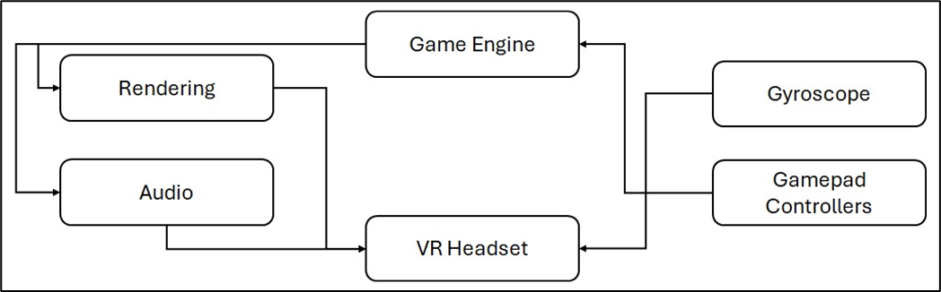

Fig. 3.3.1 Game Architecture

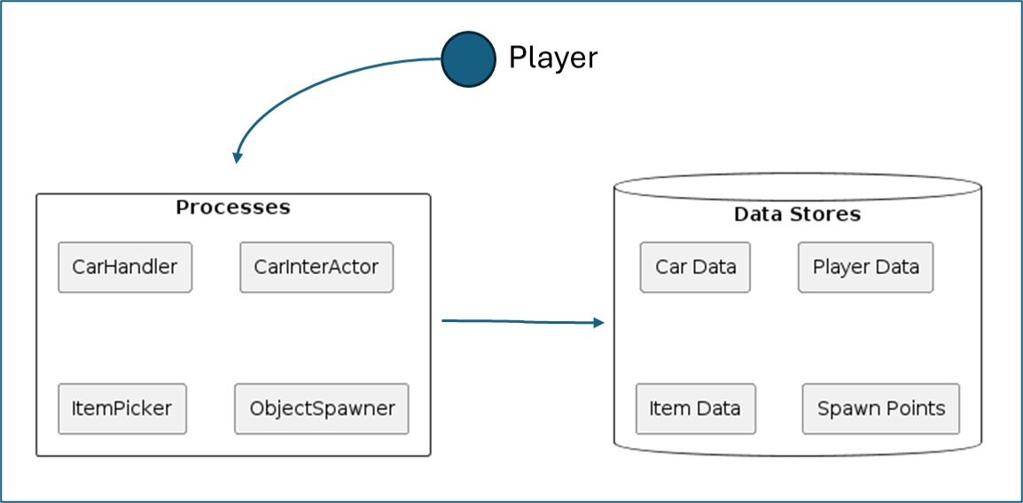

Fig. 3.3.2 DFD Level 0

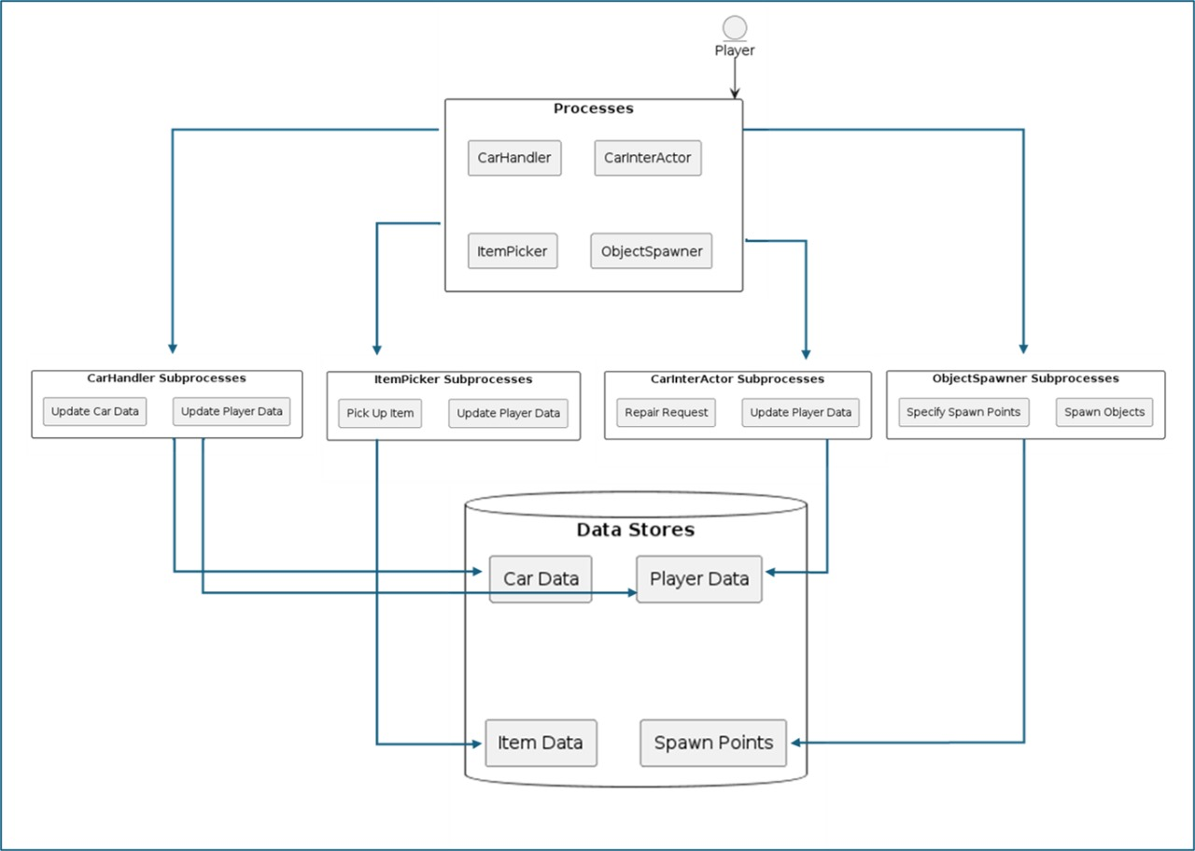

Fig. 3.3.3 DFD Level 1

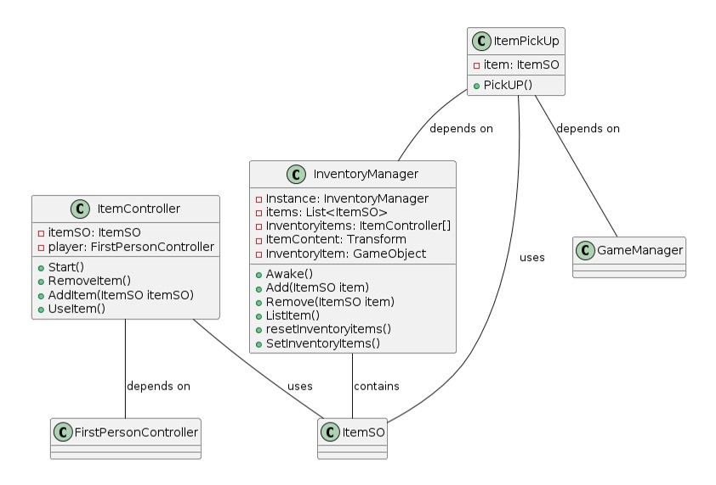

Fig. 3.3.4 Class Diagram

**3.4. Methodology**

The game is a survival horror experience, challenging players to complete all quests to achieve victory.

**1. Object Collection:** Players collect various items essential for completing tasks and progressing.

**2. AI Enemies:** AI enemies relentlessly search players, instilling a constant sense of terror.

**3. Google Cardboard SDK:** Integrates VR functionalities on Android devices, including stereoscopic rendering and headtracking.

**4. Gyroscope:** Utilizes sensor data to track players' head movements, enhancing immersion.

**5. Game manager:** The central hub oversees game elements like states, UI, input, events, logic, and win-loss condition. It synchronizes the elements to ensure a cohesive player experience.

**6.** **Item Spawner:** The algorithm enhances game replayability by randomly spawning items from strategically positioned points across the map.

**7. Audio Management:** Implements 3D spatial audio, ambient music, and eerie sounds for a heightened atmosphere.

**8. User Interface (UI):** VR-friendly UI elements provide essential information and enhance player interaction.

**9. Win Condition:** Victory is achieved by completing all tasks and escaping from pursuing enemies.

**10. Lose Condition:** Failure occurs when players are caught by enemies, leading to game over.

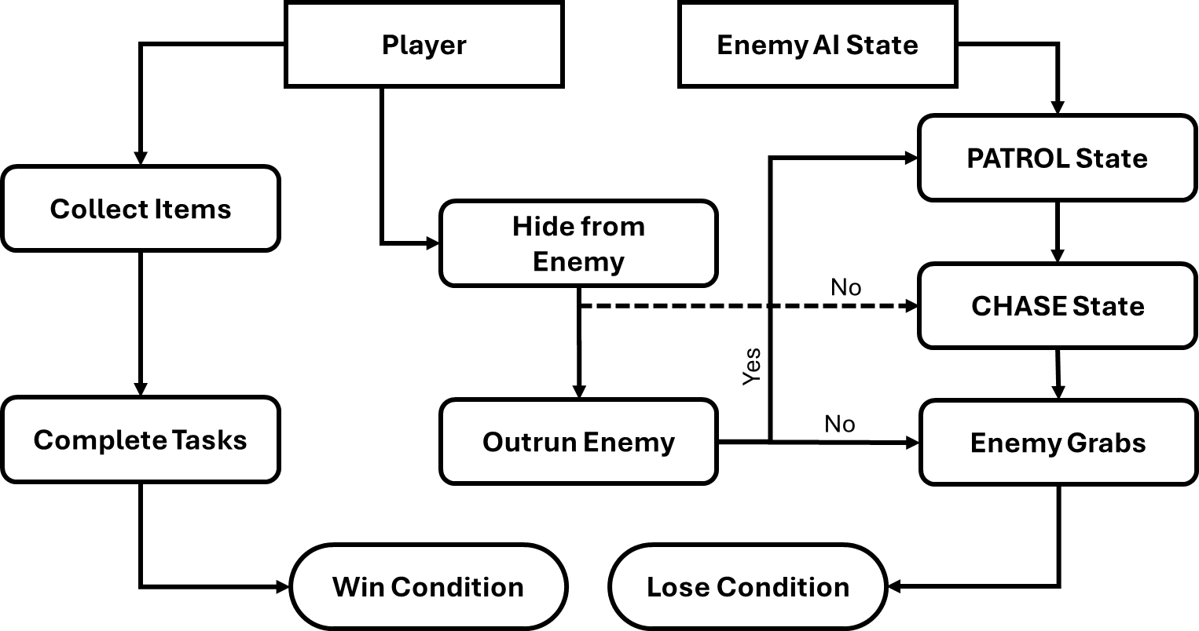  
Fig. 3.4.1 Game Mechanism

**3.5. Implementation**

**System Features**

**3.5.1. HEAD TRACKING:**

Head tracking in the VR horror games on Android will be implemented using Google Cardboard SDK which uses the device's built-in sensors, particularly the gyroscope. These sensors detect the user's head movements, including rotation and tilt. Unity's Android VR integration allows to access this sensor data and update the virtual camera's position and orientation accordingly.

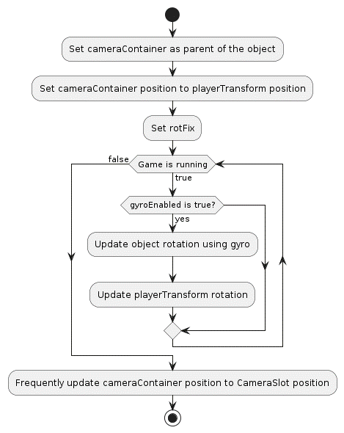

Fig. 3.5.1 Gyroscopic head tracking flowchart

**3.5.2 ITEM PICKUP & SPAWNER:**

The game uses raycasting for item pickup, enabling players to interact with virtual objects. When the player's VR camera focuses on an object, a ray is cast from the camera's position. If this ray intersects with an interactable object, players can trigger a pickup by pressing a button on their VR controller. Raycasting offers a natural and intuitive interaction method, enhancing immersion and gameplay in the VR horror experience.

The game objects spawn at specified spawn points. The game engine randomly selects spawn points from corresponding lists and instantiates objects based on the specified count, ensuring a varied and engaging gameplay experience. This approach adds randomness and unpredictability to the game world, enhancing player exploration and interaction with objects throughout the game.

Tyres and other items spawn randomly at designated positions

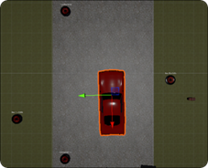 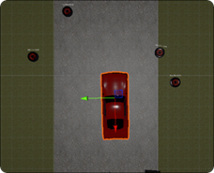

Fig. 3.5.2 Random Item Spawner

**3.5.3 ENEMY AI:**

The enemy's AI is designed with various states like idle, patrol, chase, grab, and return to patrol. These states dynamically change based on player proximity and randomized movement algorithms, creating suspenseful gameplay. To navigate the terrain, the enemy utilizes a Nav Mesh Agent for smooth movement. The patrol radius gradually reduces over time, adding strategic depth to the enemy's movements and behaviour.

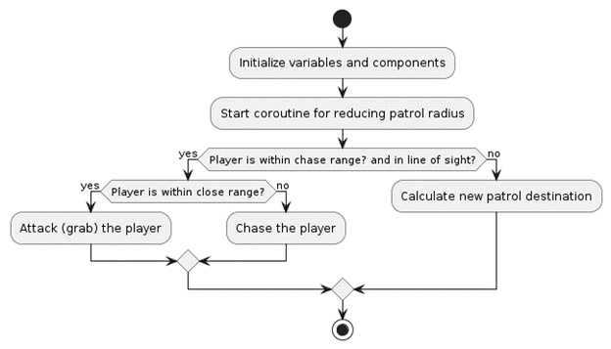

Fig. 3.5.3 Enemy AI Behaviour Flowchart

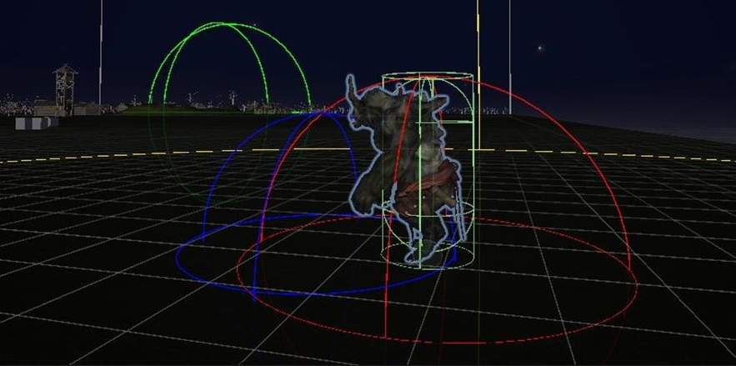

Fig. 3.5.4 Enemy in PATROL State

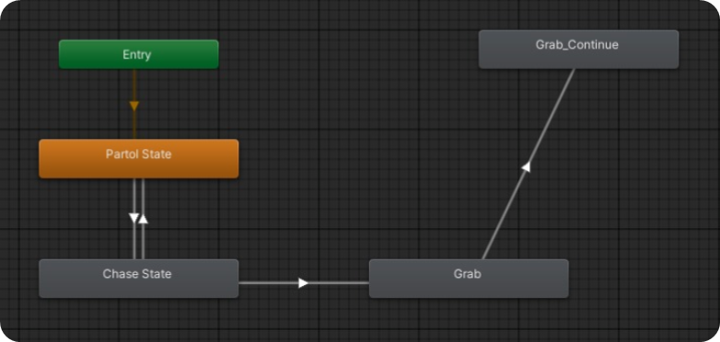

Fig. 3.5.5 Enemy <Animator> Component

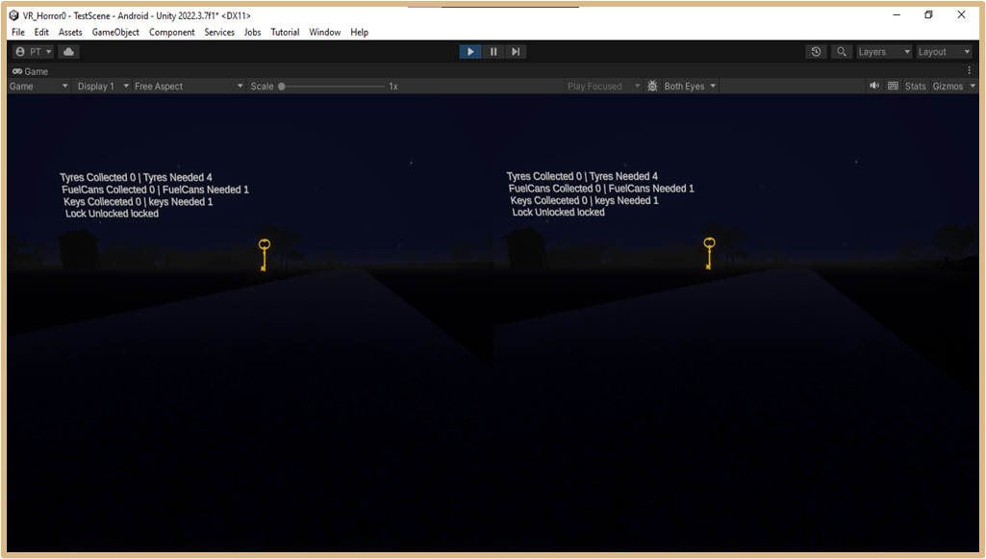

Fig. 3.5.6 Stereoscopic Game Interface

**3.5.4 GAME MAP:**

Game maps play a crucial role as they provide players with a structured environment to navigate and explore. Well-designed maps not only guide players through the game but also prevent confusion and aimless wandering. The map is crafted with diverse topography, offering varied challenges and encounters. It includes strategically placed elements and eerie audio settings, creating an immersive atmosphere that enhances the overall gameplay experience.

**4. TEST CASES**

Table 4.1: Test Cases

|  |  |  |  |  |
| --- | --- | --- | --- | --- |
| Sr. No. | Name | Input | Output | Type |
| 1 | Environment and Navigation | Gamepad Controller and Gyroscope | The player can navigate through the virtual environment and interact with objects in the environment using VR controllers | Functionality |
| 2 | Gameplay Mechanics | Interactive Objects, Pickable Objects, Enemy, Repairable Objects, Movement | Gameplay mechanics such as puzzle-solving, hiding from enemies. | Functionality |
| 3 | Visual and Audio Effects | Textures, Materials, Lighting, Footsteps Sound, Environmental Sounds, Enemy Audio | Visual effects create the intended atmosphere for a horror experience. | Functionality |
| 4 | User Interface and Controls | Inventory Panel, Captions, Health Bar, Journal | Ensure that the user interface elements are clear and readable in VR. | User  Interface |
| 5 | Compatibility and Integration | Android Devices, Windows | Test compatibility with different input devices to ensure consistent functionality across platforms | Usability Test |

**5. CONCLUSION & FUTURE SCOPE**

Our VR horror game incorporates a holistic approach to gaming, seamlessly blending immersive environments with advanced technology while catering to the traditional enthusiasm for consuming horror stories. It represents a fusion of past, present, and future elements, presenting VR seamlessly into daily life experiences. Adhering to VR rules and integrating cohesive features, our game sets a new standard for immersive entertainment.

Integration of advanced comfort settings and locomotion techniques, such as teleportation, snap turning, and field-of-view adjustments, to minimize motion sickness symptoms. Implementation of dynamic storytelling elements, nonlinear narratives, and branching paths to enhance player agency and immersion in VR horror environments. Addressing concerns about eye health due to prolonged VR headset use, future VR games may incorporate features such as regular breaks, adjustable display settings, and eye-tracking technology to mitigate potential risks and promote safe VR experiences.

Expanding on multiplayer capabilities, future beginner VR horror games may introduce cooperative or competitive modes for shared immersive experiences. Additionally, offering downloadable content (DLC) can extend gameplay longevity with new levels, characters, or storylines. Optimization efforts will focus on enhancing performance across VR platforms for smoother and more immersive gameplay experiences.

**REFERENCES**

1. Zhang, Ruiqi. "Research on the Progress of VR in Game." Highlights in Science, Engineering and Technology 39 (2023): 103-110.
2. Bian, Shijie. "Research on the Application of VR in Games." Highlights in Science, Engineering and Technology 39 (2023): 389-394.
3. Lin, Tammy Jin-Hsuan. "Virtual Reality Horror Games and Fear in Gaming." In Oxford Research Encyclopedia of Communication. 2023.
4. de Lima, Edirlei Soares, Bruno MC Silva, and Gabriel Teixeira Galam. "Adaptive virtual reality horror games based on Machine learning and player modeling." Entertainment Computing 43 (2022): 100515.
5. Zhang, Ziwen. "Analysis of the design aesthetics and player emotions of horror games: Take ‘Little Nightmares’ as a case." (2022).

1. Årnell, Tobias, and Nikola Stojanovic. "Horror game design–what instills fear in the player?: A study on the effects of horror game design theories and level design patterns on player behaviour in a horror environment." (2020).
2. Lin, Jih-Hsuan Tammy, Dai-Yun Wu, and Chen-Chao Tao. "So scary, yet so fun: The role of self-efficacy in enjoyment of a virtual reality horror game." New Media & Society 20, no. 9 (2018): 3223-3242.
3. Ntokos, Konstantinos. "Level of fear”: Analysis of fear spectrum into a tool to support horror game design for immersion and fear." An International Journal (CGDEIJ) 1, no. 33-43 (2018).

**PUBLICATIONS BY THE CANDIDATES**

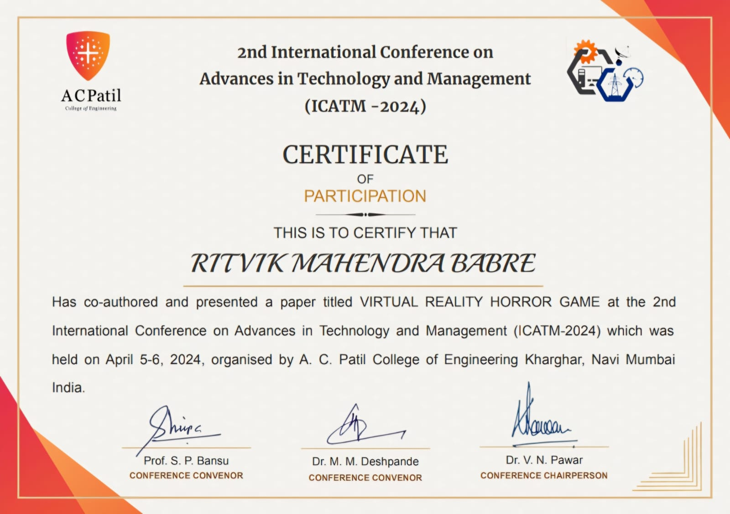



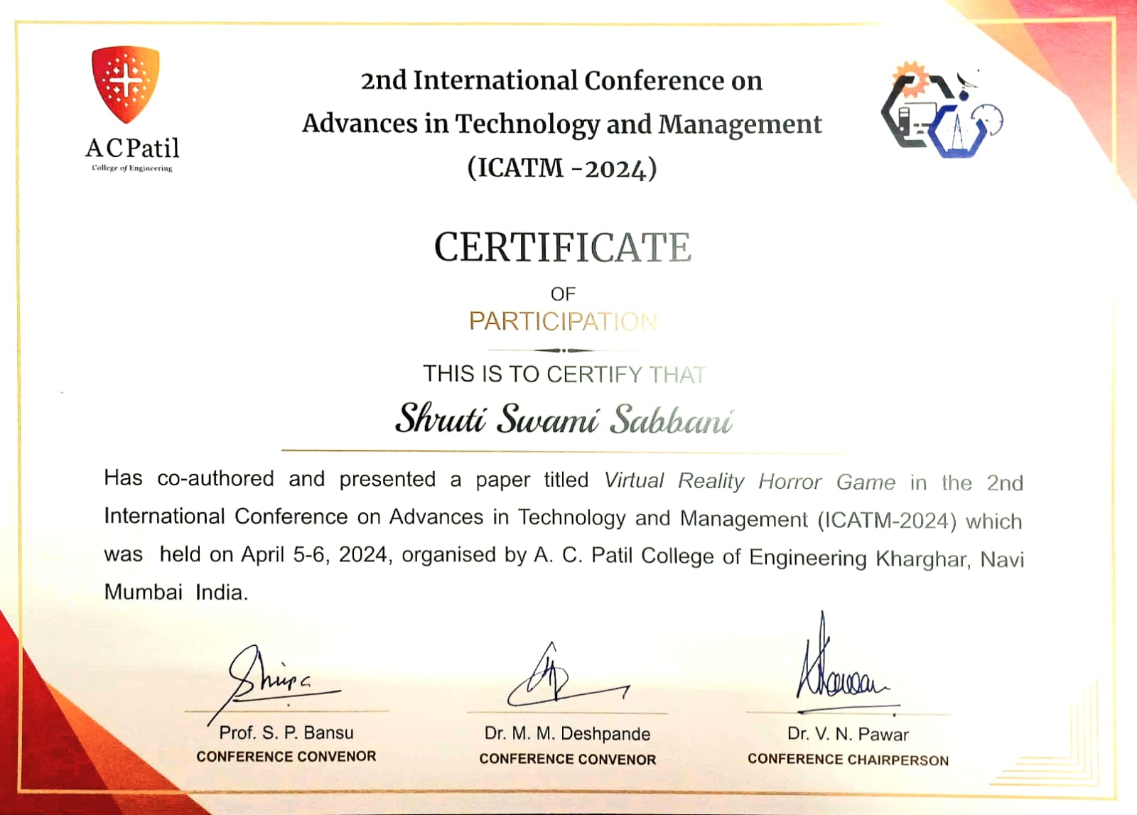

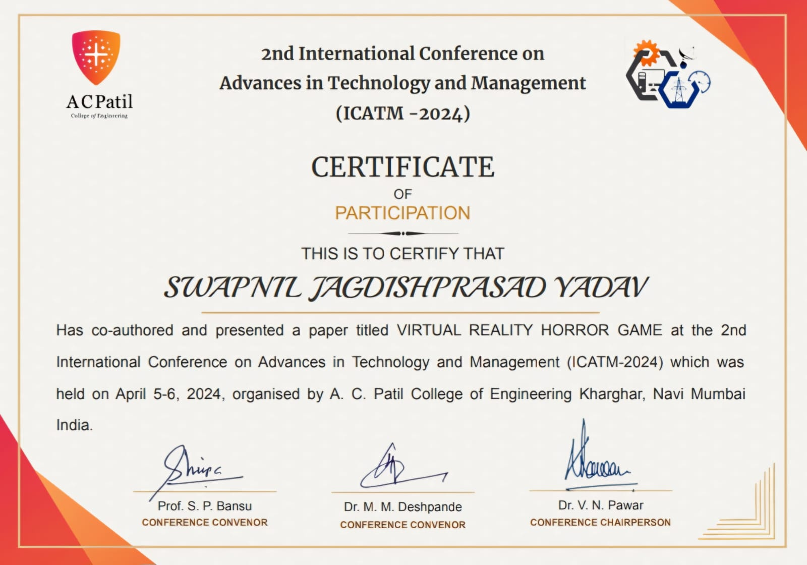

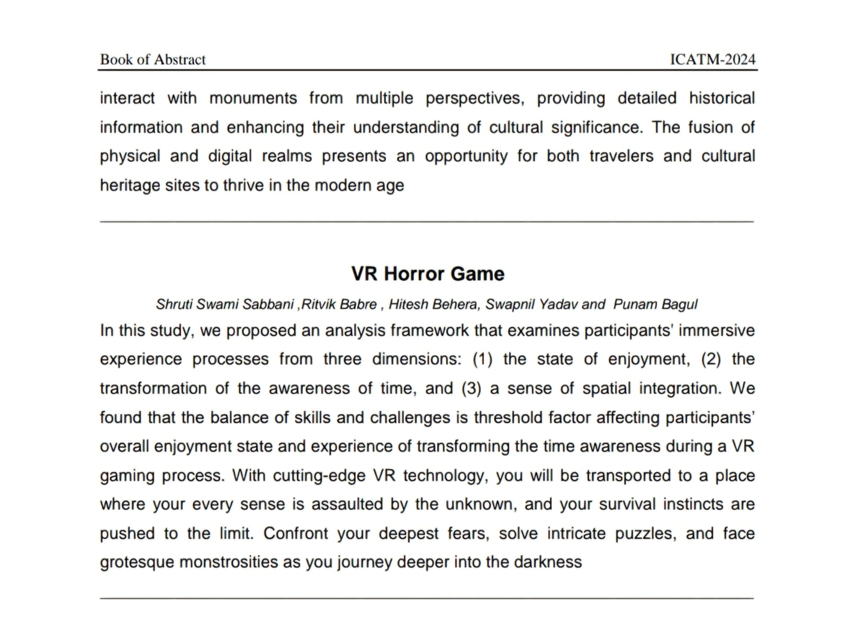

<https://icatm.in/>

